**Don’t Let Your Child’s Smartness Depend on Artificial Intelligence**

[Dr. Neha Bansal](https://www.practo.com/share/app/doctor/594742" \t "_blank)

Pediatrician

[View Full profile](https://www.practo.com/share/app/doctor/594742" \t "_blank)

21 March, 2018

If you (or anybody for that matter) ask your child ‘Why is the sky blue?’ and your smart kid quickly picks up the mobile and asks Siri (Apple’s artificial intelligence mechanism) the same and reverts. You feel proud for a second that your child is so smart at such a tender age, to use a smartphone with that much ease.

We are sorry to burst the bubble, but that’s not your child’s smartness or intelligence, and even if it is, it’s artificial. It’s a trend these days that even before children learn how to speak and walk, they know the shortcuts of the smartphones. Even though that looks pretty impressive, it does permanently affect your child’s mind.

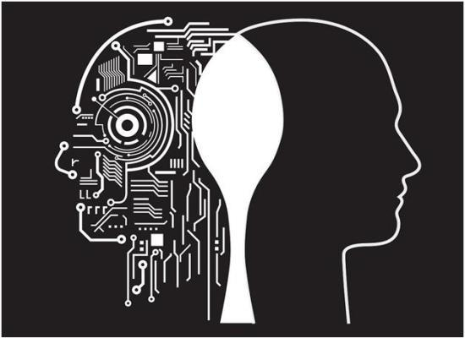

To be clearer, when your child depends on a machine’s logical thinking rather than using his own, he is increasingly being dependent on that source rather than exploring his own creativity and talent. It can be harmful to your child’s intelligence quotient in the longer run.

Dr Neha Bansal identifies this problem in most of her patients these days and advised immediate rectification of daily mistakes parents are making in raising their children. So, what can be done to ensure that children grow up to be naturally smart rather than depending on artificial intelligence for dealing with their day-to-day chores? Dr Neha Bansal suggests some measures:

* **School Homework**



Do not let your children take help from the internet to complete their home work. It makes it easier for them as well as you, but in reality, they aren’t learning anything. They are just copying the information from one place to another. Give them books and ask them to find answers to given questions. Reading and finding answers from a book is much more appreciated and useful.

* **Physical Activities**

Don’t let your child depend entirely on gadgets for entertainment. Encourage outdoor games and activities. It not only ensures good physical health but enhances mental health as well. Children learn from their surroundings and therefore it is important for them to spend time outside as well.

* **No internet**



Even if you are providing gadgets to your children on time-basis, make sure they don’t have access to the internet. There is a certain age to be introduced to the web, and your school going children do not need it.

If your child is already addicted, you need to take medical help, even a psychologist if the need arises.